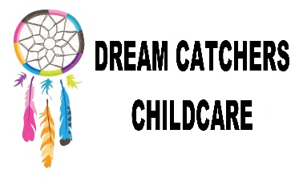
Child Protection Policy
Policy Written by – Mrs Leah Cardey
Date originally written – 10.06.16
Reviewed – 02.06.17

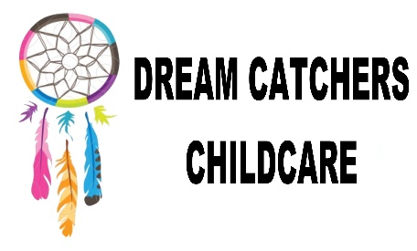

Child Protection Policy

Dream Catchers Childcare fully recognise its responsibilities for child protection. Our policy applies to all staff and volunteers working in the setting.

The four main elements to our policy are to:
- Ensure we practice safe recruitment in checking the suitability of staff, volunteers and members to work with the children.

- Raise awareness of child protection issues and equip children with the skills needed to keep them safe.

- Develop and implement procedures for identifying and reporting cases, or suspected cases of abuse.

- Establish a safe environment in which children can learn and develop.

We recognise that, because of the day to day contact with children, staff are well placed to observe the outward signs of abuse. All staff have knowledge on child protection and safeguarding.

The setting will therefore:

- Establish and maintain an environment where children feel secure, are encouraged to talk and are listened to.

- Ensure children know there are staff in the setting whom they can approach if they are worried.

- Include opportunities in the setting planning for children to develop the skills they need to recognise and stay safe from all forms of abuse.

We will follow the procedures set out by Local Safeguarding Children’s Board (LSCB) and take account of guidance issued by the DCSF (Dept of children, school and families) to:

- Ensure we have a designated senior person for child protection who has received appropriate training and support for this role.

- Ensure every member of staff (including temporary and volunteers) knows the name of the designated senior person responsible for child protection and their role.

- Ensure all staff and volunteers understand their responsibilities in being alert to the signs of abuse and responsibility for referring any concerns to the designated senior person responsible for child protection.

- Ensure that parents have an understanding of the responsibility placed on the setting and staff for child protection.

- Notify social services if there is an unexpected absence of more than two days of a pupil who is on the child protection register.

- Develop effective links with relevant agencies and cooperate as required with their enquiries regarding child protection matters, including attendance at case conferences.

- Keep written records of concerns about children, even where there is no need to refer the matter immediately.

- Ensure all records are kept securely; separate from the child’s personal file.

- Develop and follow procedures where an allegation is made against a member of staff or volunteers.

- Ensure safe recruitment practices are always followed.

We recognise that children who are abused or witness violence may find it difficult to develop a sense of self-worth. They may feel helplessness, humiliation and some sense of blame. The setting could be a secure and predictable element in the lives of many children at risk. Whilst at the club their behaviour may be challenging and defiant or they may be withdrawn.
The setting will endeavour to support the child through:
- The settings ethos which promotes a positive, supportive and secure environment and gives children a sense of being valued.

- The setting will support the vulnerable children through any challenging behaviour by following the settings behaviour policy.

- To ensure the child knows that some behaviour is unacceptable but they are valued and not to be blamed for any abuse which has occurred.

- Liaison with other agencies that support the child such as social services and Child and Adult Mental Health Service (CAHMS).

- Ensure that, where a child on the child protection register leaves, their information is transferred to the new setting and that the child’s social worker is informed.

Child protection common meanings:
‘Significant Harm;
This concept was introduced by the Children’s Act 1989 as the threshold for intervention in family life for protection of children ‘Harm’ Ill-treatment or the impairment of health or development, including for example, impairment suffered from seeing or hearing the ill treatment of another ‘Development’ Physical, Intellectual, emotional, social, or behavioural development
Threshold for significant harm
There is no absolute criteria on which to rely on. Significant harm can be caused by one traumatic event or a compilation of events that interrupt, change or damage the child’s physical or psychological development.

Dream Catchers Childcare’s lead Child Protection Officer is: Mrs L Cardey.

Important Contacts
Dream Catchers Childcare’s lead Child Protection Officer is: Mrs L Cardey.
Portsmouth's Local Authority Designated Officer (LADO) is Denise Lingham- 02392 882500 - lado@portsmouthcc.gcsx.gov.uk
Multi Agency Safeguarding Hub (MASH) 02392- 688793
At all other times, phone the out-of-hours service on 0300 555 1373
NSPCC - 24 Hour helpline 0808 800 5000
Ofsted - 0300 123 4234 enquires@ofsted.gov.uk

