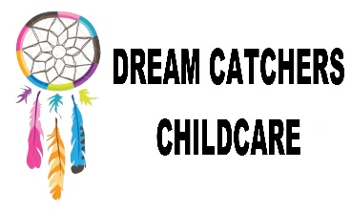
Equal Opportunities and Diversity Policy
Policy Written by – Mrs Leah Cardey
Date originally written – 10.06.16
Reviewed – 02.06.17

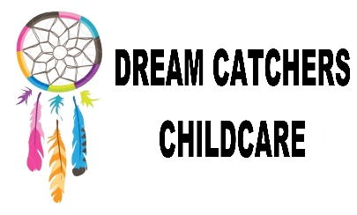

Equal Opportunities

We will make sure that we actively promote equality of opportunity and anti-discriminatory practices for all children. We will make sure that I treat all children with equal concern and respect.

Procedure;
- We recognise and welcome all legislation and existing codes of practice produced by appropriate commissions, for example the Equality and Human Rights commission.

- We value and respect the different racial origins, religions, cultures and languages in a multi-ethnic society so that each child is valued as an individual without racial or gender stero-typing. We will also not discriminate against children on the grounds of disability, sexual orientation, age, class, family status and HIV/AIDS status.

- We provide equal chances for each child to learn and develop to their full potential, taking into account each child’s age and stage of development, gender, ethnicity, home language and ability.

- We will ensure that children are offered a wide variety of activities and resources that offer a view on different diversity’s.

- We will challenge all racist and discriminatory remarks, attitudes and behaviour from the children in our care as well as any adults.

- We will always support, encourage and help children to feel good about themselves and others by celebrating the differences which make us all unique.

- We will help each child to reach their full potential and this may mean altering or adjusting an activity.

