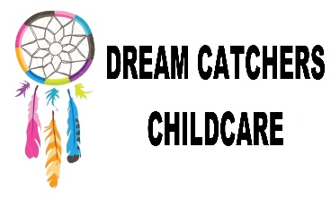

Information Sharing Forms

Policy Written by – Mrs Leah Cardey
Date originally written – 10.06.16
Reviewed – 02.06.17

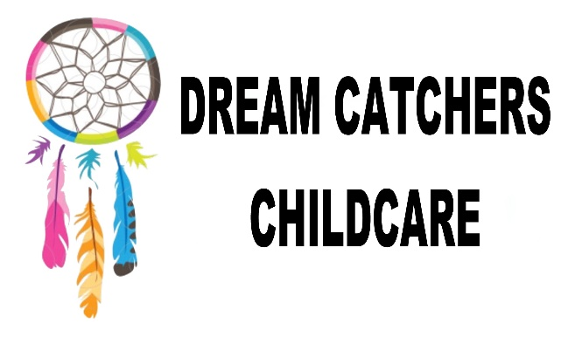

Information Sharing

Dream Catchers childcare recognises that all children are individual and have different strengths, abilities and needs. Information sharing is key to delivering better, more efficient services and care, that are coordinated around the needs of the individual child. Information sharing is a vital element in improving outcomes for all.

To ensure a consistent approach and level of care, I/we agree to Dream Catchers childcare contacting the school which………………………………………………… attends and agree that both Dream Catchers and the school can provide or share information as well as discussing matters relating to the education, wellbeing or behaviour of my child.

Parent name (Print) ………………………………………………………..

Signature…………………………………………………………………………

Date…………………………………………………………………………………

